# Kanban – Inside sales

The prebuilt *Kanban – Inside Sales* gives the user an extremely good overview of all scheduled phone calls, with each Kanban column representing when the phone call is scheduled. The last column represents phone calls that have been completed within the last week.

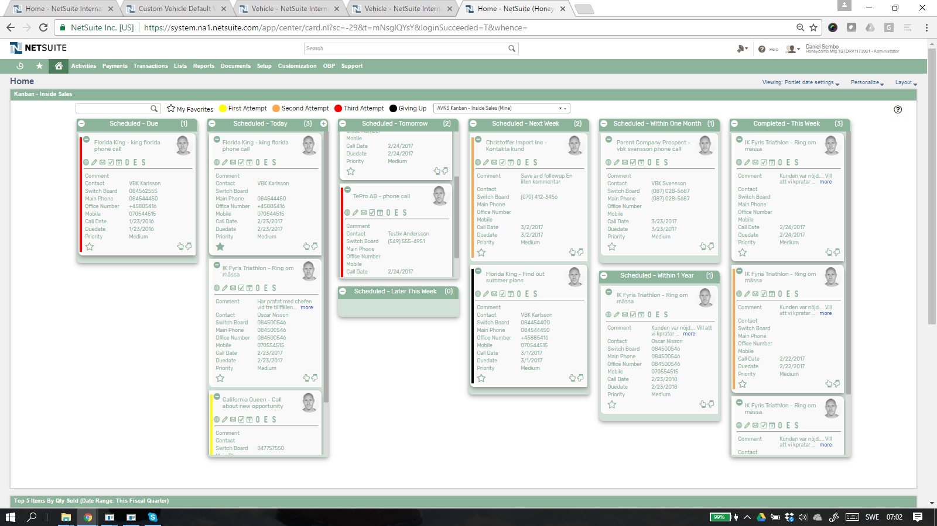

### Kanban – Inside Sales: Prerequisites

Before using the *Kanban – Inside Sales*, please make sure the prerequisites listed below are fulfilled in order for the board to function as expected.

1. **Employee Image**  
   Make sure to uploaded an *Image* field on each Employee record, this image will be displayed on the Kanban card if the employee is assigned to the phone call. If no image is available, a predefined profile icon will be displayed instead.
2. **Customer 360**  
   Make sure that Report 360 (bundle id: xxxxx and bundle id: yyyyy) is installed. Otherwise customer 360 report won´t work.

### 

### Kanban – Inside Sales: Card Moves & Column Actions

The *Kanban – Inside Sales* board contains eight Kanban Columns. Each column has been configured with one or several Column Actions. Double clicking on any card in the *Kanban – Inside Sales* board will open the phone call record in edit mode.  


1. **Scheduled - Due**
   1. *Card Moves* – Kanban cards in the column *Scheduled - Due* can be moved to all other columns in the Kanban board. It is not allowed to move a card to this column. All phone calls that are due will automatically end up in this column.
2. **Scheduled - Today**
   1. *Card Moves* – Kanban cards in the column *Scheduled - Today* can be moved to all other columns in the Kanban board besides Scheduled - Due.
   2. *Column Actions* – when moving a Kanban card to the column *Scheduled – Today,* the Call Date field will be updated and set to today.
   3. *Add Card* – Is only available in this column. It opens a new phone call that by default is scheduled today and assigned to the user. 
3. **Scheduled - Tomorrow**
   1. *Card Moves* – Kanban cards in the column *Scheduled - Tomorrow* can be moved to all other columns in the Kanban board besides Scheduled - Due.
   2. *Column Actions* – when moving a Kanban card to the column *Scheduled – Tomorrow,* the Call Date field will be updated and set to tomorrow.
4. **Scheduled – Later this Week**
   1. *Card Moves* – Kanban cards in the column *Scheduled – Later this Week* can be moved to all other columns in the Kanban board besides Scheduled - Due**.**
   2. *Column Actions* – when moving a Kanban card to the column *Scheduled – Later this Week,* the Call Date field will be updated and set to Friday this week.
5. **Scheduled – Next Week**
6. *Card Moves* – Kanban cards in the column *Scheduled – Next Week* can be moved to all other columns in the Kanban board besides Scheduled - Due.
7. *Column Actions* – when moving a Kanban card to the column *Scheduled – Next Week,* the Call Date field will be updated and set to 7 days from today.
8. **Scheduled – Within One Month**
9. *Card Moves* – Kanban cards in the column *Scheduled – Within One Month* can be moved to all other columns in the Kanban board besides Scheduled - Due.
10. *Column Actions* – when moving a Kanban card to the column *Scheduled – Within One Month,* the Call Date field will be updated and set to 28 days from today (28 to make sure it is the same weekday).
11. **Scheduled – Within One Year**
12. *Card Moves* – Kanban cards in the column *Scheduled – Within One Year* can be moved to all other columns in the Kanban board besides Scheduled - Due.
13. *Column Actions* – when moving a Kanban card to the column *Scheduled – Within One Year,* the Call Date field will be updated and set to 364 days from today (364 to make sure it is the same weekday).
14. **Completed – This Week**
15. *Card Moves – Kanban cards in the column Completed – This Week can’t be moved. If you like to move a card from this column you have to open the phone call and edit status manually.*
16. *Column Actions – when moving a kanban card to the column Completed – This week, the phone call status will be set to completed.****OBS!*** *Sometimes when you complete a phone call you like to follow up on this phone call later. Use standard netsuite function, save and follow up (save & copy) This will create a new phone call that you manually can schedule. When you have saved this new phone call you will have to refresh the kanban board before it appears.*

### Kanban – Inside Sales: Available Card Actions

The Kanban cards in the *Kanban – Inside Sales* board each contains nine Card Actions. 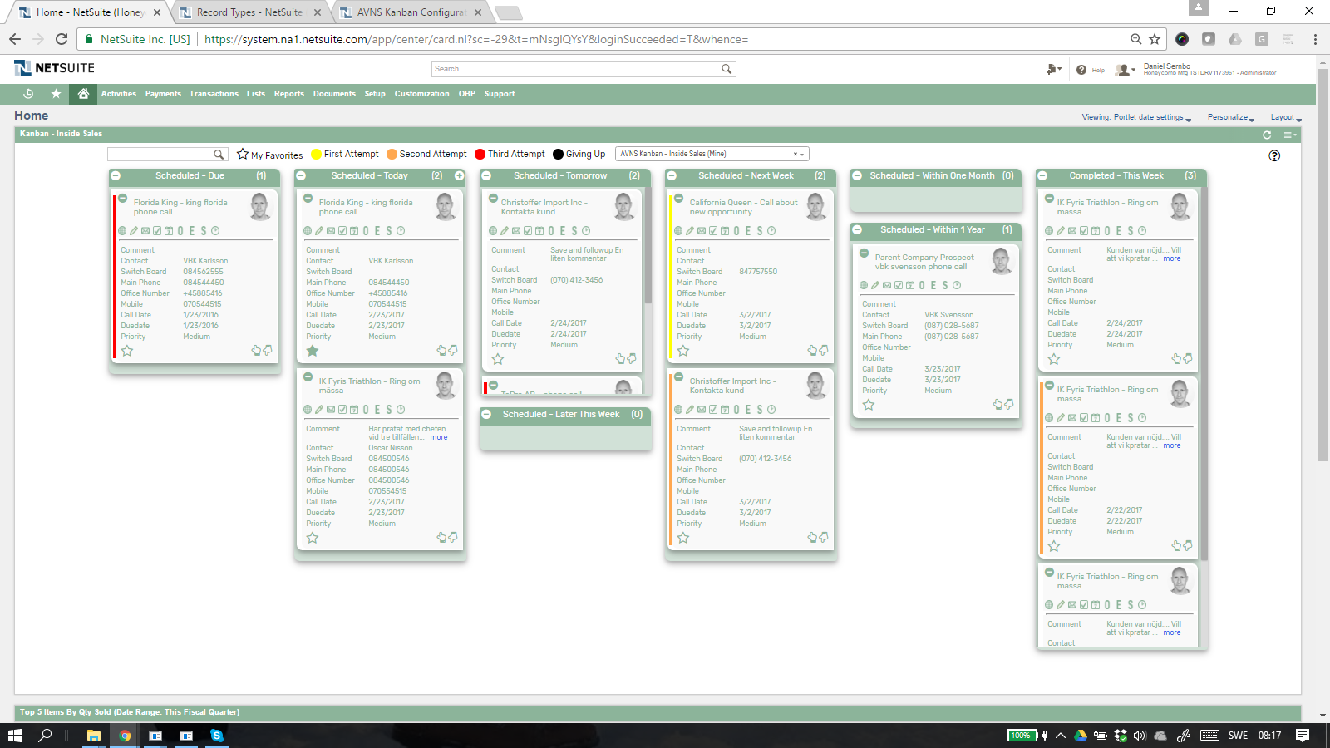

1. **Phone: View Customer 360**View Customer 360 report for current customer.
2. **Phone: New Note**Add a new note attached to the phone call.
3. **Phone: Send Email**Send a email to the customer contact from the Kanban card.
4. **Phone: New Task**Create a new task connected to the customer from the   
   Kanban card.
5. **Phone: New Event**Invite the customer contact to a new event from the   
   Kanban card.
6. **Phone: New Opportunity**Create a new opportunity to the customer from the Kanban   
   card.
7. **Phone: New Estimate**Create a new estimate to the customer from the Kanban card.
8. **Phone: New Sales Order**Create a new Sales Order to the customer from the Kanban card.
9. **Phone: New Time Entry**Create a new Time Entry for time you spent on the phone with the customer.

### Kanban – Inside Sales: Alternative Searches

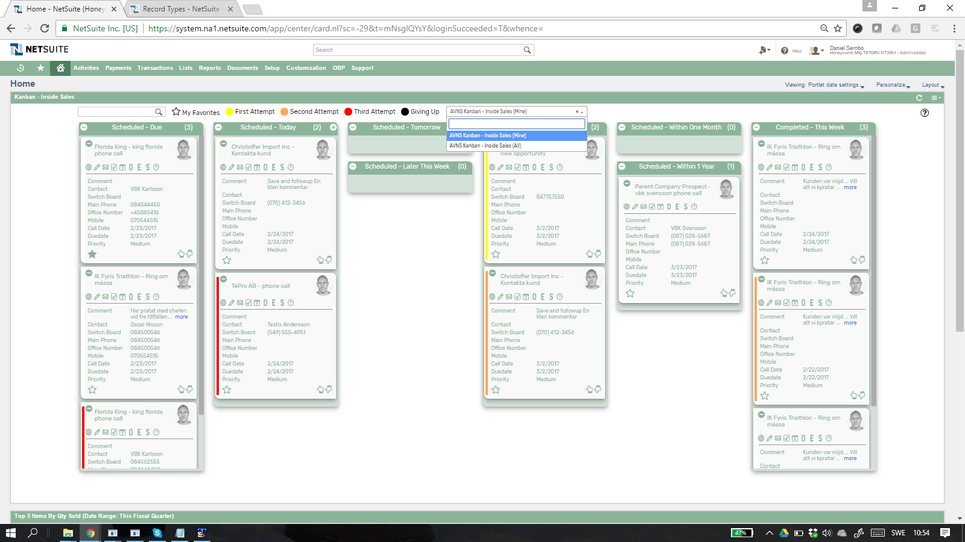There are two alternative searches for the *Kanban – Inside Sales* board.  


1. **AVNS Kanban – Inside Sales (All)**This search will display all registered Customer Phone Calls in the *Kanban – Inside Sales* board.
2. **AVNS Kanban – Inside Sales (Mine)**This search will display registered Customer Phone Calls assigned to current user in the *Kanban – Inside Sales* board.

### Kanban – Prospects: Available Colors

There are fore colors available for the *Kanban – Inside Sales* board, which can be used to highlight and filter the Kanban cards (First Attempt *// Second Attempt // Third Attempt // Giving Up*). These are defined in the *Color* subtab of the Kanban configuration record.   
  
